# CSE 5234 – Distributed Enterprise Computing

Lab 6 – User Interface tier for Web Applications

The goal of this lab is to give students a good understanding of how to use HTML 5, CSS 3, and JavaScript to build user interface tier for a modern web application. Students will build upon the application created in the previous lab.

# Objectives

1. Create a professional looking web site with multiple pages & structure using HTML.
2. Improve look and feel of existing web pages by using a stylesheet.
3. Add client-side validation to user input (optional).

# Detailed Requirements

* The website should have a home page, which will be the landing page.
* The website could have a separate products page (if you chose to have home page with attractive and dynamic marketing graphics for your customers).
* The website should have an “About Us” page, which contains the following:
  + Brief company mission and vision
  + Company strategy statement
  + “Meet our Executives” section which includes a image of each team member, their job title (brag!!), education/experience/passion. Brag, brag, brag!!
  + Make it look professional to your potential investors)
* The website should include a “Contact Us” page. This is meant for “after-sale” support. You should have details on how and who the customers can contact, with returns/issues/help etc. You can include your support/return policies, and FAQ. (Hint: copy/paste from your favorite vendor’s site, have ChatGPT generate content for you.
* The website should have a professional and consistent menu.
* The website should have a consistent footer. Look up professional websites how that is done.

# Implementation Instructions & Guidelines

* Mockup of a highly simplistic website is included in the appendix. That should help to clarify some of the requirements. Don’t copy the style, I expect your website to be a lot better!
* I have provided some of the styles in the appendix. If you want to use these, copy it into a css file. I recommend that you try using Bootstrap < <https://getbootstrap.com/> >
* Use CSS to control the layout of tables. Look at the example in <http://www.w3schools.com/css/css_table.asp> (hint: view page source, inspect header section of the page, and borrow stylesheet.
* Use Gen AI tools at your disposal to generate and/or style content.

Appendix

# Mockup of MyGolf purchase items page:

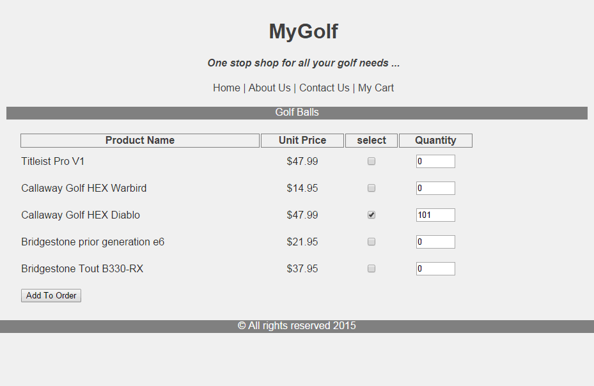

# Mystylesheet.css (example)

@CHARSET "ISO-8859-1";

html {

color: #2E2E2E;

font-family: Arial, Helvetica, sans-serif;

background-color: #F2F2F2;

max-width: 980px;

}

body {

margin: 0px;

padding: 0px;

height: 100%;

}

.header {

padding: 10px;

width: 100%;

text-align: center;

background-color: #F2F2F2;

color: #424242;

}

.body {

margin: 10px;

}

.footer {

clear: both;

position: inherit;

bottom: 0;

left: 0;

text-align: center;

width: 100%;

height: 20px;

background-color: #808080;

color:#fff;

}

.prodheading {

width: 100%;

height: 20px;

background-color: #808080;

color: #fff;

text-align: center;

vertical-align: middle;

}

.prodContainer {

position: inherit;

height: auto;

float: left;

}

table {

width: 80%;

margin-top: 20px;

}

td, td.center-col {

height: 40px;

}

td.center-col {

text-align: center;

}

td.right-col {

text-align: right;

padding-right: 15px;

}

th {

color: #424242;

border:1pt solid #808080;

}

td.tot {

color: #424242;

border:1pt solid #808080;

}

.tableContainer {

padding-left: 20px;

}

#wrapper {

margin-left:auto;

margin-right:auto;

height:auto;

width:auto;

}

.button-bar {

float:left;

clear: both;

}

.explanation {

padding-left: 10px;

font-size: x-small;

}

.confirmation {

text-align: center;

}